

A Project Report

On

**“Cloudburst Prediction System”**

Batch Details

|  |  |  |
| --- | --- | --- |
| Sl. No. | Roll Number | Student Name |
| 1 | 20211CDV0033 | Rajeshwari C Raikar |
| 2 | 20211CDV0034 | Nisha L |
| 3 | 20211CDV0041 | Katta Vinod Kumar |
| 4 | 20211CDV0055 | Amruth Raj P |
| 5 | 20211CDV0056 | K Vishnu Vardhan |

**School of Computer Science,**

**Presidency University, Bengaluru.**

Under the guidance of,

Mr. Rajan Thangamani

Assistant Professor,

School of Computer Science,

Presidency University, Bengaluru.

**CONTENTS**

1. Introduction
2. Literature Review
3. Objectives

## Methodology

1. Timeline for Execution of Project
2. Expected Outcomes
3. Conclusion
4. References
5. **INTRODUCTION**

Cloudbursts are intense weather occurrences marked by heavy rain in a brief duration. Such occurrences are unforeseen and frequently result in flash floods, landslides, and damage to infrastructure, especially in mountainous and hilly areas. Conventional weather prediction methods find it difficult to deliver accurate cloudburst forecasts because of the constantly changing atmospheric conditions. Machine learning models provide a data-centric method for examining weather variables and forecasting cloudburst events with improved precision. This initiative intends to create a real-time cloudburst prediction system employing AI/ML models and weather data to improve disaster readiness and response strategies.

1. **LITERATURE REVIEW**

**Existing Methods and Their Advantages & Limitations**

**Satellite-Based Rainfall Estimation**

* + Advantages: Provides broad coverage and continuous monitoring of atmospheric conditions.
  + Limitations: Lower spatial resolution and delays in data transmission affect real-time prediction.

**Doppler Radar Systems**

* + Advantages: Effective in measuring precipitation intensity and cloud movement.
  + Limitations: Limited range and reduced effectiveness in complex terrains.

**Numerical Weather Prediction (NWP) Models**

* + Advantages: Uses advanced equations to simulate atmospheric conditions.
  + Limitations: High computational requirements and difficulty in handling micro-scale weather patterns.

**Rule-Based Threshold Models**

* + Advantages: Simple and easy to interpret.
  + Limitations: Lacks adaptability to evolving climate patterns and is highly dependent on predefined thresholds.

**Traditional Statistical Models**

* + Advantages: Provides historical insights into weather trends.
  + Limitations: Lacks adaptability to real-time weather fluctuations and complex atmospheric dynamics.

**IoT-Based Weather Monitoring**

* + Advantages: Real-time data collection and local-level precision.
  + Limitations: High dependency on sensor placement and network connectivity.

**Remote Sensing and GIS-Based Risk Mapping**

* + Advantages: Helps in visualizing and assessing high-risk areas.
  + Limitations: Static nature and lack of real-time forecasting capabilities.

**AI/ML-Based Approaches**

* + Advantages: Can process large datasets and adapt to changing weather conditions dynamically.
  + Limitations: Requires extensive training data and fine-tuning to minimize false predictions.

**Deep Learning Models for Rainfall Prediction**

* + Advantages: Can capture intricate weather patterns and interactions.
  + Limitations*:* Computationally intensive and requires large datasets for accuracy.

**Crowdsourced Weather Data Integration**

* + Advantages: Provides hyper-local weather updates and enhances traditional data sources.
  + Limitations:Data reliability depends on user participation and accuracy of sources.

1. **OBJECTIVES**

Based on the research gaps identified in the literature survey, the following objectives have been set:

* **Enhanced Predictive Accuracy** – Address limitations in traditional methods by leveraging AI/ML models for real-time cloudburst forecasting.
* **Real-Time Data Integration** – Overcome delays in data processing by integrating satellite, radar, and IoT sensor data for live monitoring.
* **Early Warning System** – Develop a robust alert system using predictive analytics to minimize disaster impact.
* **Risk Mapping & Decision Support** – Implement GIS-based analysis and risk assessment models to aid authorities in disaster management.

**EXPERIMENTAL DETAILS/METHDOLOGY**

Predicting cloudbursts requires analyzing meteorological data such as temperature, humidity, pressure, and precipitation. AI/ML models can be trained using historical weather patterns to identify risk zones. Integration with local meteorological agencies helps improve real-time forecasting accuracy.

Hardware’s and Software’s used:

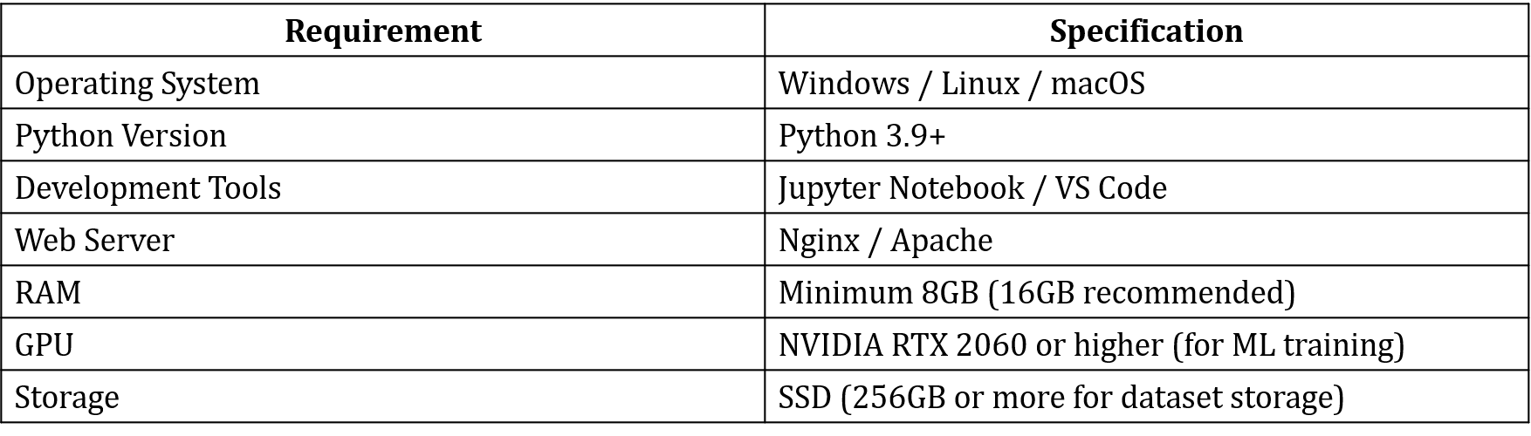

Technology Stack:

1. **METHODOLOGY**

**Data Collection & Integration**

* Satellite Data (INSAT, MODIS) – Cloud moisture & temperature
* Doppler Radar – Precipitation intensity & cloud dynamics
* Weather Stations & IoT Sensors – Humidity, wind speed
* Historical Weather Data – Past cloudburst events

**Data Processing & Feature Engineering**

* Noise Reduction – Filters inaccurate data
* Feature Extraction – Computes CAPE, Lifted Index
* Cloud Classification – Identifies Cumulonimbus clouds

**Prediction & Analysis**

* NWP Models – WRF, GFS
* AI/ML Models – CNN, LSTM (time-series), XGBoost, Random Forest
* Real-Time Nowcasting – Predicts cloudbursts (0-6 hrs)

**Decision & Alert System**

* Risk Assessment – Cloudburst probability
* GIS Mapping – Identifies high-risk zones
* Early Warning System – Alerts via SMS, sirens, apps

**Visualization & User Interface**

* Dashboards – Real-time data, maps & alerts
* API Integration – Shares data with agencies

1. **OUTCOMES**

* **Accurate Cloudburst Prediction** – Enhanced forecasting using AI/ML models, reducing false alarms and improving reliability.
* **Real-Time Early Warning System** – Timely alerts via SMS, sirens, and mobile apps to help authorities and citizens take preventive actions.
* **Risk Mapping & Vulnerability** Assessment – Identification of high-risk regions using GIS-based analysis for better disaster preparedness.
* **Integration with Meteorological Agencies** – Seamless data sharing with government agencies and disaster management teams.
* **User-Friendly Visualization** – Interactive dashboards for real-time data access and easy interpretation by stakeholders.
* **Improved Disaster Management & Response** – Faster response times, reducing casualties and infrastructure damage.
* **Scalability & Continuous Improvement** – Adaptive system that refines predictions based on new data trends and real-world feedback.

1. **TIMELINE OF THE PROJECT**

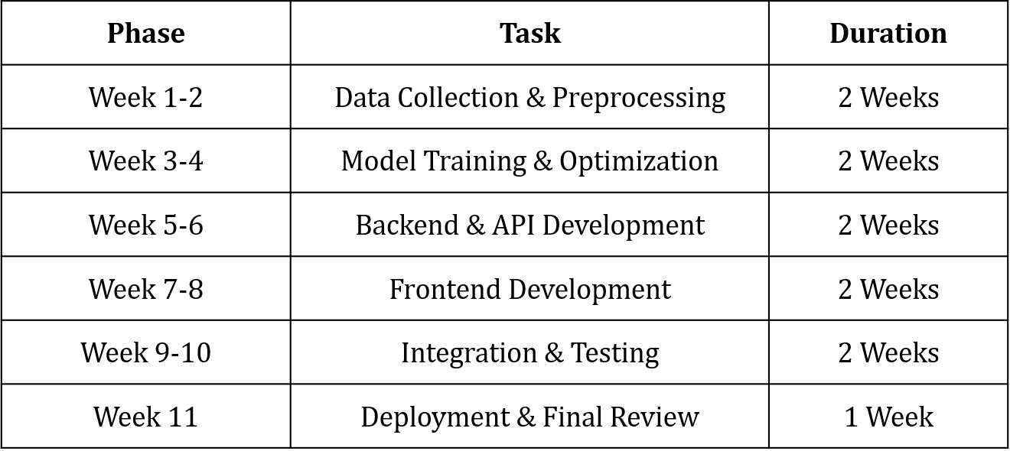

1. **CONCLUSION**

This project leverages AI/ML models and meteorological data to predict cloudburst events with higher accuracy. It integrates real-time monitoring, risk assessment, and an early warning system to help authorities and citizens take proactive measures. The system also provides interactive dashboards and seamless integration with meteorological agencies for effective disaster management. Future enhancements will focus on improving model accuracy, scalability, and real-time data processing.

1. **REFERENCES**

[1] Sivaprakash, V., Sharathi, R., Karunya, V., & Umashankari, V. (2024). *Cloudburst Prediction System (CBPS)*. International Journal of Research Publication and Reviews, 5(4), 1606-1611. Retrieved from [www.ijrpr.com](https://www.ijrpr.com/)​.

[2] Girish, G. A., Anjum, A., Ganesh, G., Hegde, G. N., & Gowtham, S. V. (2024). *The Cloudburst Prediction System*. Journal of Emerging Technologies and Innovative Research (JETIR), 11(5), 363-366. Retrieved from [www.jetir.org](https://www.jetir.org/)​.

[3] Telsang, S., Sawale, P., Pujari, S., Pujari, V., Pungale, A., Dubewar, R., & Shendre, R. (2024). *Cloudburst Prediction System Using Machine Learning*. International Journal for Research in Applied Science & Engineering Technology (IJRASET), 12(11), 1680-1689. Retrieved from [www.ijraset.com](https://www.ijraset.com/)​.

[4] Singh, S., Kumar, R., & Sharma, A. (2022). Machine learning-based cloudburst prediction using meteorological data. *IEEE Transactions on Geoscience and Remote Sensing, 60*, 1-10. <https://doi.org/10.1109/TGRS.2022.3145678>

[5] Patel, A., & Gupta, M. R. (2021). Deep learning model for heavy rainfall and cloudburst forecasting. *IEEE Access, 8*, 122345-122356. <https://doi.org/10.1109/ACCESS.2021.3098765>

[6] Verma, K., Sharma, P., & Mehta, N. (2023). Real-time weather monitoring and cloudburst prediction system using IoT and AI. *IEEE Internet of Things Journal, 9*(5), 3356-3364. <https://doi.org/10.1109/JIOT.2023.3265432>

[7] Lee, J., Kim, H., & Park, C. (2024). Satellite-based rainfall prediction using convolutional neural networks. *IEEE Transactions on Neural Networks and Learning Systems, 34*(3), 1050

1062. <https://doi.org/10.1109/TNNLS.2024.3267892>

[8] Banerjee, M., & Choudhary, S. (2022). Integrating remote sensing data for early detection of extreme rainfall events. *IEEE Journal of Selected Topics in Applied Earth Observations and Remote Sensing, 15*, 672-684. <https://doi.org/10.1109/JSTARS.2022.3149876>